

**Faculty of Engineering**

**Electronics and communication Engineering Department**

**Matlab assignment**

**Echo generation system**

Presented by

|  |  |  |
| --- | --- | --- |
| Name | Section | BN |
| نادر عاطف لبيب | 4 | 32 |
| علي بدري عبدالنعيم | 3 | 4 |

July 2021

# 

# 

## 

## Code description:

### **Adding echo to the audio**

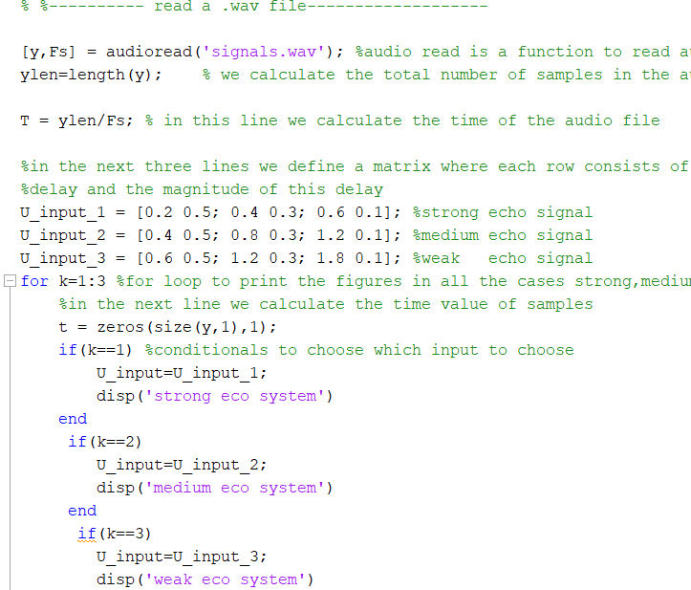

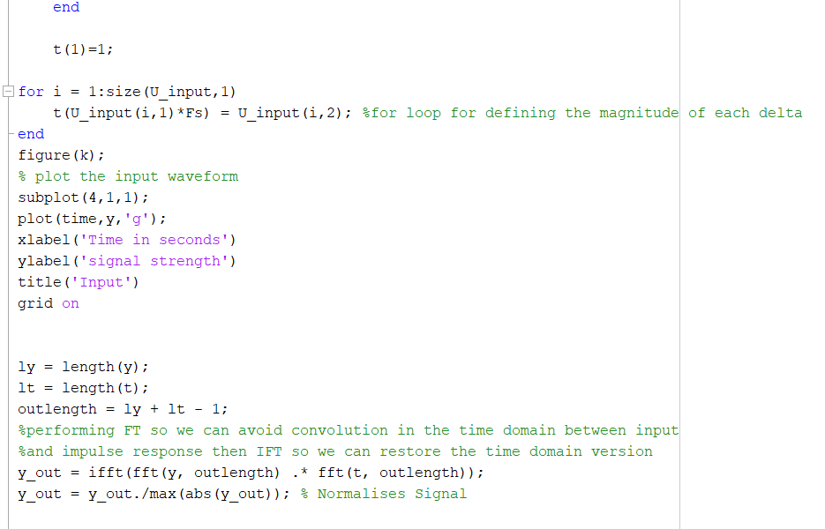

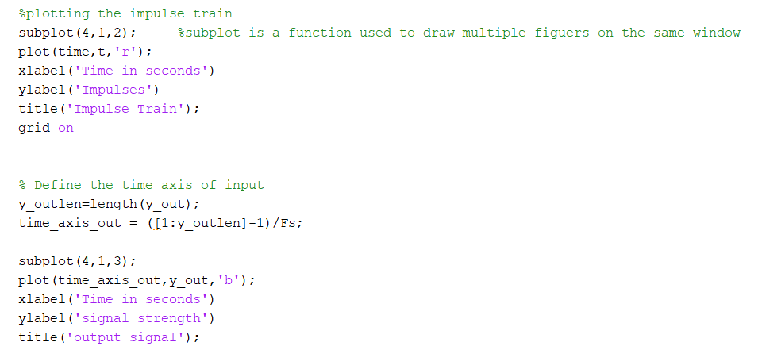

### **Removing the echo from the signal**

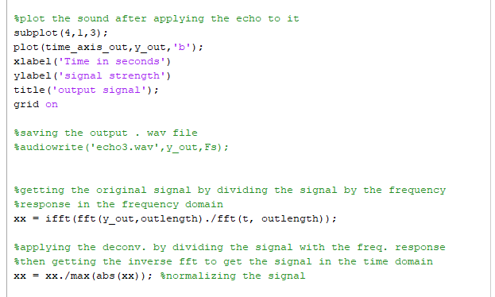

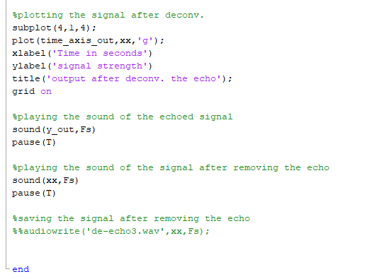

### **Output graphs:**

**Strong echo**

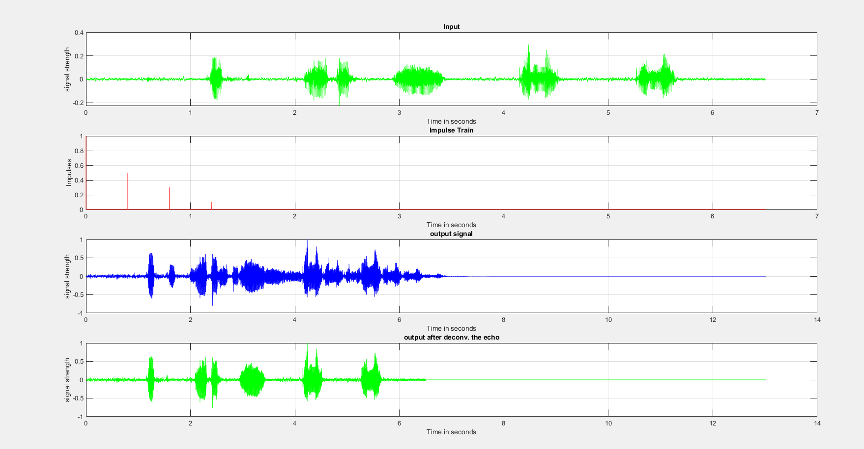

**Medium echo**

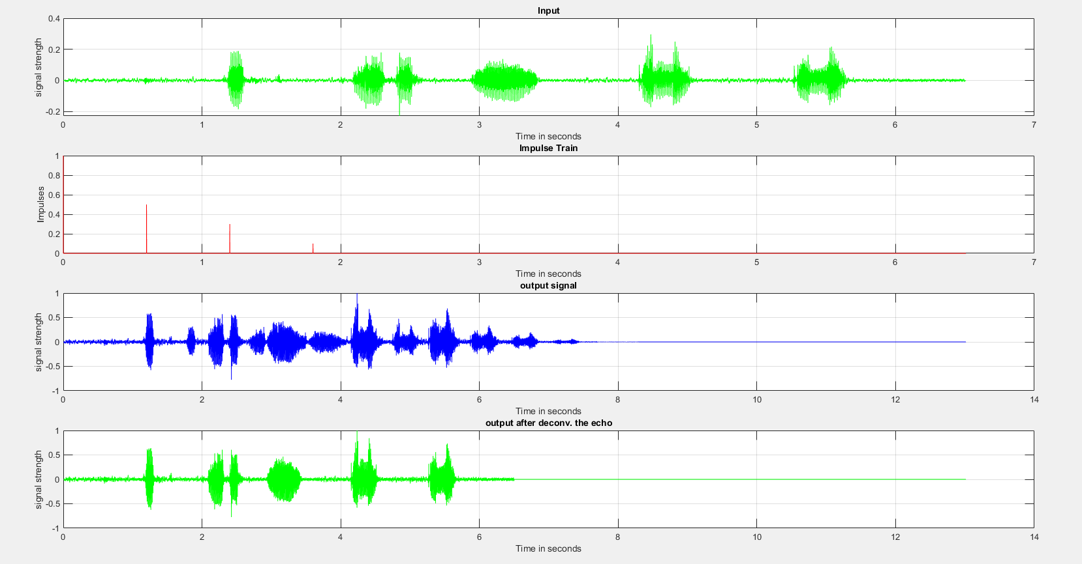 **Weak echo**